Year 6 - Arithmetic Expectations
This series of documents aims to summarise the number facts, mental calculation strategies and the stage(s) of the progression towards the written methods for each of the four operations.
For each strategy, the concrete and pictorial representations have been suggested. However, to keep the document to a more manageable size, the imagery has not been shown explicitly as this should be found in your school’s agreed mental calculations policies.
The strategies used within this document are taken from the Lancashire Mathematics Team Progression in Mental Calculation Strategies Policies and the Progression Towards Written Methods Policies.
See www.lancsngfl.ac.uk/curriculum/primarymaths for the full policies.

Each strategy will require specific modelling (teaching) and sufficient practice for children to develop confidence, accuracy and fluency in performing them.
Children should also be taught when it is appropriate to use each strategy, by looking at the numbers involved and making effective decisions. Again, this is a sign of a child’s fluency in mathematics; being able to recognise which strategy best suits a given calculation, rather than always using the same method regardless of the numbers involved.

Acknowledgements
Special thanks to the following teachers who helped to create these documents:
Sue Byrom – Colne Park Primary Naomi Tyson – Gisburn Road Community Primary Hannah Blackburn – Lowerhouse Juniors
Tara Warbrick – Colne Park Primary Nick Browne – Gisburn Road Community Primary Jess Dornan – Lowerhouse Juniors
Jane Dempsey – Burnley Springfield Primary Laura Mitchell – Burnley St Stephen’s CE Primary Michelle Hume – Whittlefield Primary
Andrew Douglas – Burnley Springfield Primary Moira Waller – Burnley St Stephen’s CE Primary Stephen Riley – Whittlefield Primary

Arithmetic Expectations – Year 6
Skills | Examples
Counting
Count forwards and backwards in steps of integers, decimals and powers of 10. | Count from 0 in steps for multiplication facts for up to 12x tables  What number would come next in this counting sequence? 0, 10, 100, 1000, __, __  What number is missing from this counting sequence? 0, 0.01, 0.02, 0.04, 0.05
Find 0.001, 0.01, 0.1, 1 10 and powers of 10 more/less than a given number. | 500 +/- 0.001 =  9.46 +/- 0.01 =  What is 1000 more than ____?  What is 0.1 less than ____?
Number Facts
Recall and use addition and subtraction facts for 1 (with decimals to two decimal places) | 1 = 0.05 + __ 0.95 + __ = 1 __ + 0.8 = 1  0.09 + __ = 1 0.23 + __ = 1 __ + 0.4 = 1
Multiply and divide numbers by 10, 100, 1000 giving answers up to three decimal places | 345 x 10 = 4598 ÷ 10 = 452 ÷ __ = 4.52  894 x 100 = 2098 ÷ 100 = 109 x __ = 10900
Mental Calculation Strategies – Addition and Subtraction
Partition and combine multiples of thousands hundreds, tens and ones  Concrete (if necessary) – place value counters  Pictorial – number line | 5800 + 2400 5800 add 2000 and 400 = 5800 add 2000 add 400  873 + 350 873 add 300 and 50 = 873 add 300 add 50  4100 - 1600 4100 take away 1000 and 600 = 4100 take away 1000 take away 600  2132 - 440 2132 take away 400 and 40 = 2132 take away 400 take away 40  5124 + 1352 5124 add 1000 and 300 and 50 and 2 = 5124 add 1000 add 300 add 50 add 2 (crossing no boundaries)  7584 - 2351 7584 take away 2000 and 300 and 50 and 1 = 7584 take away 2000 take away 300 take away 50 take away1 (crossing no boundaries)
Partition and combine multiples of ones and tenths  Concrete (if necessary) – place value counters  Pictorial – number line | 8.4 + 3.8 8.4 add 3 and 0.8 = 8.4 add 3 add 0.8  13.2 – 4.5 13.2 take away 4 and 0.5 = 13.2 take away 4 take away 0.5
Identify and use knowledge of number bonds within a calculation and identify related facts, e.g. 680 + 430, 6.8 + 4.3, 0.68 + 0.43 can all be worked out using the related calculation 68 + 43  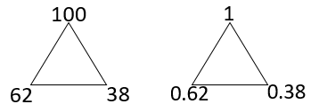  Concrete (if necessary) – place value counters  Pictorial – related facts addition trios | 0.62 + 0.38 using knowledge of 62 + 38 = 100  0.75 + 0.56 using knowledge of 75 + 56 = 131  2.8 + 0.43 using knowledge of 280 + 43 = 323  1 – 0.41 using knowledge of 100 – 41 = 59  0.92 – 0.35 using knowledge of 92 – 35 = 57  8.3 – 0.52 using knowledge of 830 – 52 = 778

Find differences by counting up through the next multiple of 0.1, 1, 10, 100 or 1000  Pictorial – number line | 8.2 – 3.46  14.23 – 7.58
Bridge through 10 when adding or subtracting a single digit number (partitioning, e.g. 58 + 5 = 58 + 2 + 3 or 76 – 8 = 76 – 6 – 2)  Pictorial – number line | 1.5 + 1.7 as 1.5 + 0.5 + 1.2  0.7 + 0.56 as 0.7 + 0.3 + 0.26  8.3 – 2.7 as 8.3 – 2.3 – 0.4
Add or subtract a multiple of 1 or 10 and adjust (for those numbers close to multiples of 1 or 10)  Pictorial – number line | 5.6 + 3.9 as 5.6 + 4 – 0.1  7.5 – 4.8 as 7.5 – 5 + 0.2
Mental Calculation Strategies – Multiplication and Division
Multiply whole numbers and decimals to three decimal places by 10, 100 and 1000  Pictorial – place value chart | 4562 x 1000  9.682 x 10  25.784 x 100  Th H T U t h th  4 3 7 2 1  4 3 7 2 1  Th H T U t h th  4 3 7 2 1  4 3 7 2 1
Use partitioning to double or halve any number  Concrete (if necessary) – place value counters  Pictorial – partitioning diagram | What is double 34.7?  What is half of 456?  34.5 ÷ 2 =  409 x 2 =
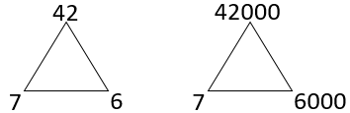  Identify and use all related facts that link to tables  Pictorial – related facts multiplication trios | 7000 x 6 becomes 7 x 1000 x 6 reordered as 7 x 6 x 1000  500 x 40 becomes 5 x 100 x 4 x 10 reordered as 5 x 4 x 100 x 10  900 x 300 becomes 9 x 100 x 3 x 100 reordered as 9 x 3 x 100 x 100  3000 x 80 becomes 3 x 1000 x 8 x 10 reordered as 3 x 8 x 1000 x 10
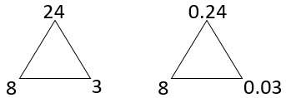  Use related facts to multiply 0.0t by a one-digit number  Pictorial – related facts multiplication trios | 0.03 x 7 related to 3 x 7 = 21  0.06 x 9 related to 6 x 9 = 54  0.05 x 4 related to 5 x 4 = 20
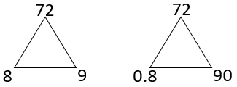  Use related facts to divide TU by 0.t  Pictorial – related facts multiplication/division trios | 56 ÷ 0.8 related to 56 ÷ 8 = 7  21 ÷ 0.7 related to 21 ÷ 7 = 3  36 ÷ 0.9 related to 36 ÷ 9 = 4  48 ÷ 0.4 related to 48 ÷ 4 = 12
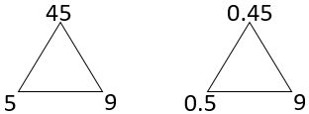  Use related facts to divide 0.th by 0.t  Pictorial – related facts multiplication/division trios | 0.32 ÷ 0.4 related to 32 ÷ 4 = 8  0.64 ÷ 0.8 related to 64 ÷ 8 = 8  0.45 ÷ 0.9 related to 45 ÷ 9 = 5

Use compensation to multiply U.9 and U.99 by a one-digit number  Pictorial – rectangle with given dimensions | 5.9 x 4 understood as 6 x 4 – 0.1 x 4  3.99 x 7 understood as 4 x 7 – 0.01 x 7  9.99 x 6 understood as 10 x 4 – 0.01 x 6
Use partitioning to multiply 0.th by a one-digit number  Pictorial – partitioning diagram | 0.76 x 3  0.28 x 7  0.54 x 6
Use partitioning to double numbers including those with three decimal places  Concrete (if necessary) – place value counters  Pictorial – partitioning diagram | Double 3.421  Double 6.705  Double 12.594  Double 54 672  Double 674 960
Divide whole numbers and decimals to three decimal places by 10, 100 and 1000  Pictorial – place value chart | 356.7 ÷ 100  9.83 ÷ 10  7.04 ÷ 10  860.2 ÷ 100  56 789 ÷ 1000
Use related facts to divide by 50  Pictorial – place value chart if necessary for initial step of ÷ 100 | 4100 ÷ 50 understood as (4100 ÷ 100) x 2  7800 ÷ 50 understood as (7800 ÷ 100) x 2  530 ÷ 50 understood as (530 ÷ 100) x 2
Use related facts to divide by 25  Pictorial – place value chart if necessary for initial step of ÷ 100 | 3200 ÷ 25 understood as (3200 ÷ 100) x 4  7600 ÷ 25 understood as (7600 ÷ 100) x 4  360 ÷ 25 understood as (360 ÷ 100) x 4
Use partitioning to divide ThHTU by a one-digit number  Concrete (if necessary) – place value counters  Pictorial – partitioning diagram | 5035 ÷ 5 by partitioning into 5000 and 35 (multiples of 5 totalling 5035)  1236 ÷ 4 by partitioning into 1200 and 36 (multiples of 4 totalling 1236)  9240 ÷ 6 by partitioning into 6000 and 3000 and 240 (multiples of 6 totalling 9240)

Progression Towards Written Calculation Strategies – Addition
This final stage of the method should have been achieved in Year 3, and should be continued to be used for all written addition calculations.  The first example would be explained as follows:  5 + 8 = 13, put 3 down and carry the 10 (written as a 1 in the tens column)  20 + 40 + 10 that was carried over = 70 (7 written in the tens column)  600 + 0 = 600 (6 written in the hundreds column)  Children will be expected to use this method for adding numbers with up to seven digits, numbers involving decimals and adding any number of amounts together.  Supported (if necessary) by the use of place value counters. | 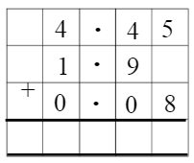  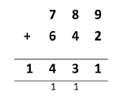
Progression Towards Written Calculation Strategies – Subtraction
This final stage is the compact method of decomposition should have been achieved in Year 4, and should be continued to be used for all written subtraction calculations.  Children will be expected to use this method for subtracting numbers with up to seven digits and numbers involving decimals.  Supported (if necessary) by the use of place value counters. | 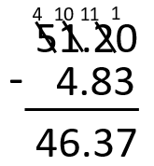  The example shown would be explained as follows:  We are subtracting 86 from 754. Start with the least  significant place value column.  Are there enough hundredths to subtract 3 hundredths?  No – so let’s exchange a tenth from the tenths column for  ten hundredths. 2 tenths and 0 hundredths becomes 41 tenth and  10 hundredths.  10 hundredths subtract 3 hundredths = 8 hundredths  Are there enough tenths to subtract 8 tenths?  No – so let’s exchange a one from the ones column for ten tenths.  1 one and 1 tenth becomes 0 ones and 1 tenths.  11 tenths subtract 8 tenths = 3 tenths.  Are there enough ones to subtract 4 ones?  No – so let’s exchange a ten from the tens column for ten ones. 5 tens and 0 ones becomes 4 tens and 10 ones  10 – 4 = 6  4 tens (40) – 0 tens = 4 tens (40)  Answer 46.37
Progression Towards Written Calculation Strategies – Multiplication
As the grid method for multiplication supports children’s number sense and appreciation of the values of each digit, schools can decide if this is the final stage of written multiplication.  It is often easier for children to keep track of the partial products calculated by using the grid method rather than the compact vertical method.  Concerns over ‘acceptable methods’ for 2 mark questions in the end of key stage 2 test should be weighed up against the improved chance of gaining 2 marks for the correct answer by using the grid method.  Optional  If schools wish to proceed to the compact vertical method for written multiplication then this is how it should progress, with different colours for the partial products to highlight how the steps taken are the same, just in a different order. | Children may be add these mentally.
Progression Towards Written Calculation Strategies – Division
As the chunking method for division supports children’s number sense and appreciation of the values of each digit, schools can decide if this is the final stage of written division. It can be used for both short and long division (Year 6 expectation) and leads to more efficient mental methods.  As children develop their understanding of this method, they should use ever more efficient steps. The menu box may not need to be written, but the children should continue to think in this way. | 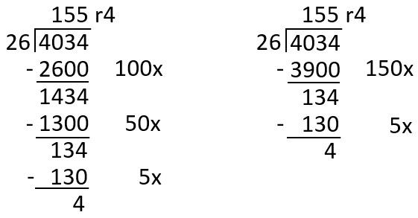  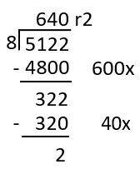
Decision Making
When calculating, children should ask themselves:
- do I know the answer because it is a fact I have learnt?
- can I work it out easily in my head?
- can I use some equipment or a jotting?
- do I need to use the written method?
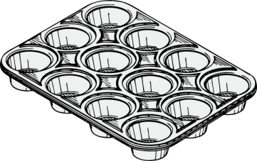
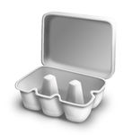
The strategies used within this document are taken from the Lancashire Mathematics Team Progression in Mental Calculation Strategies Policies and the Progression Towards Written Methods Policies.
See www.lancsngfl.ac.uk/curriculum/primarymaths for the full policies.

