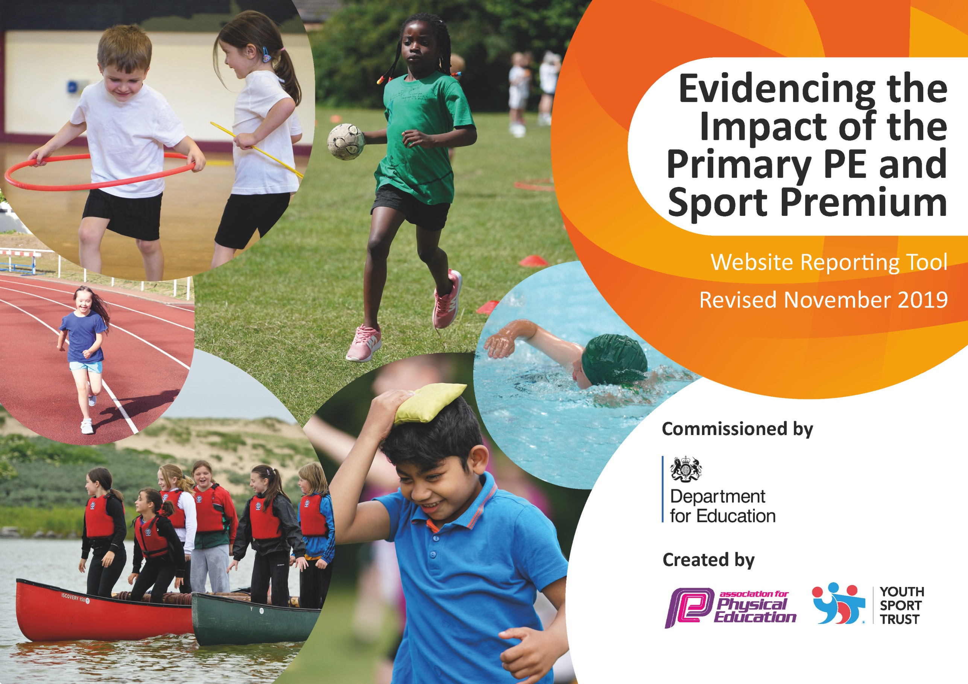
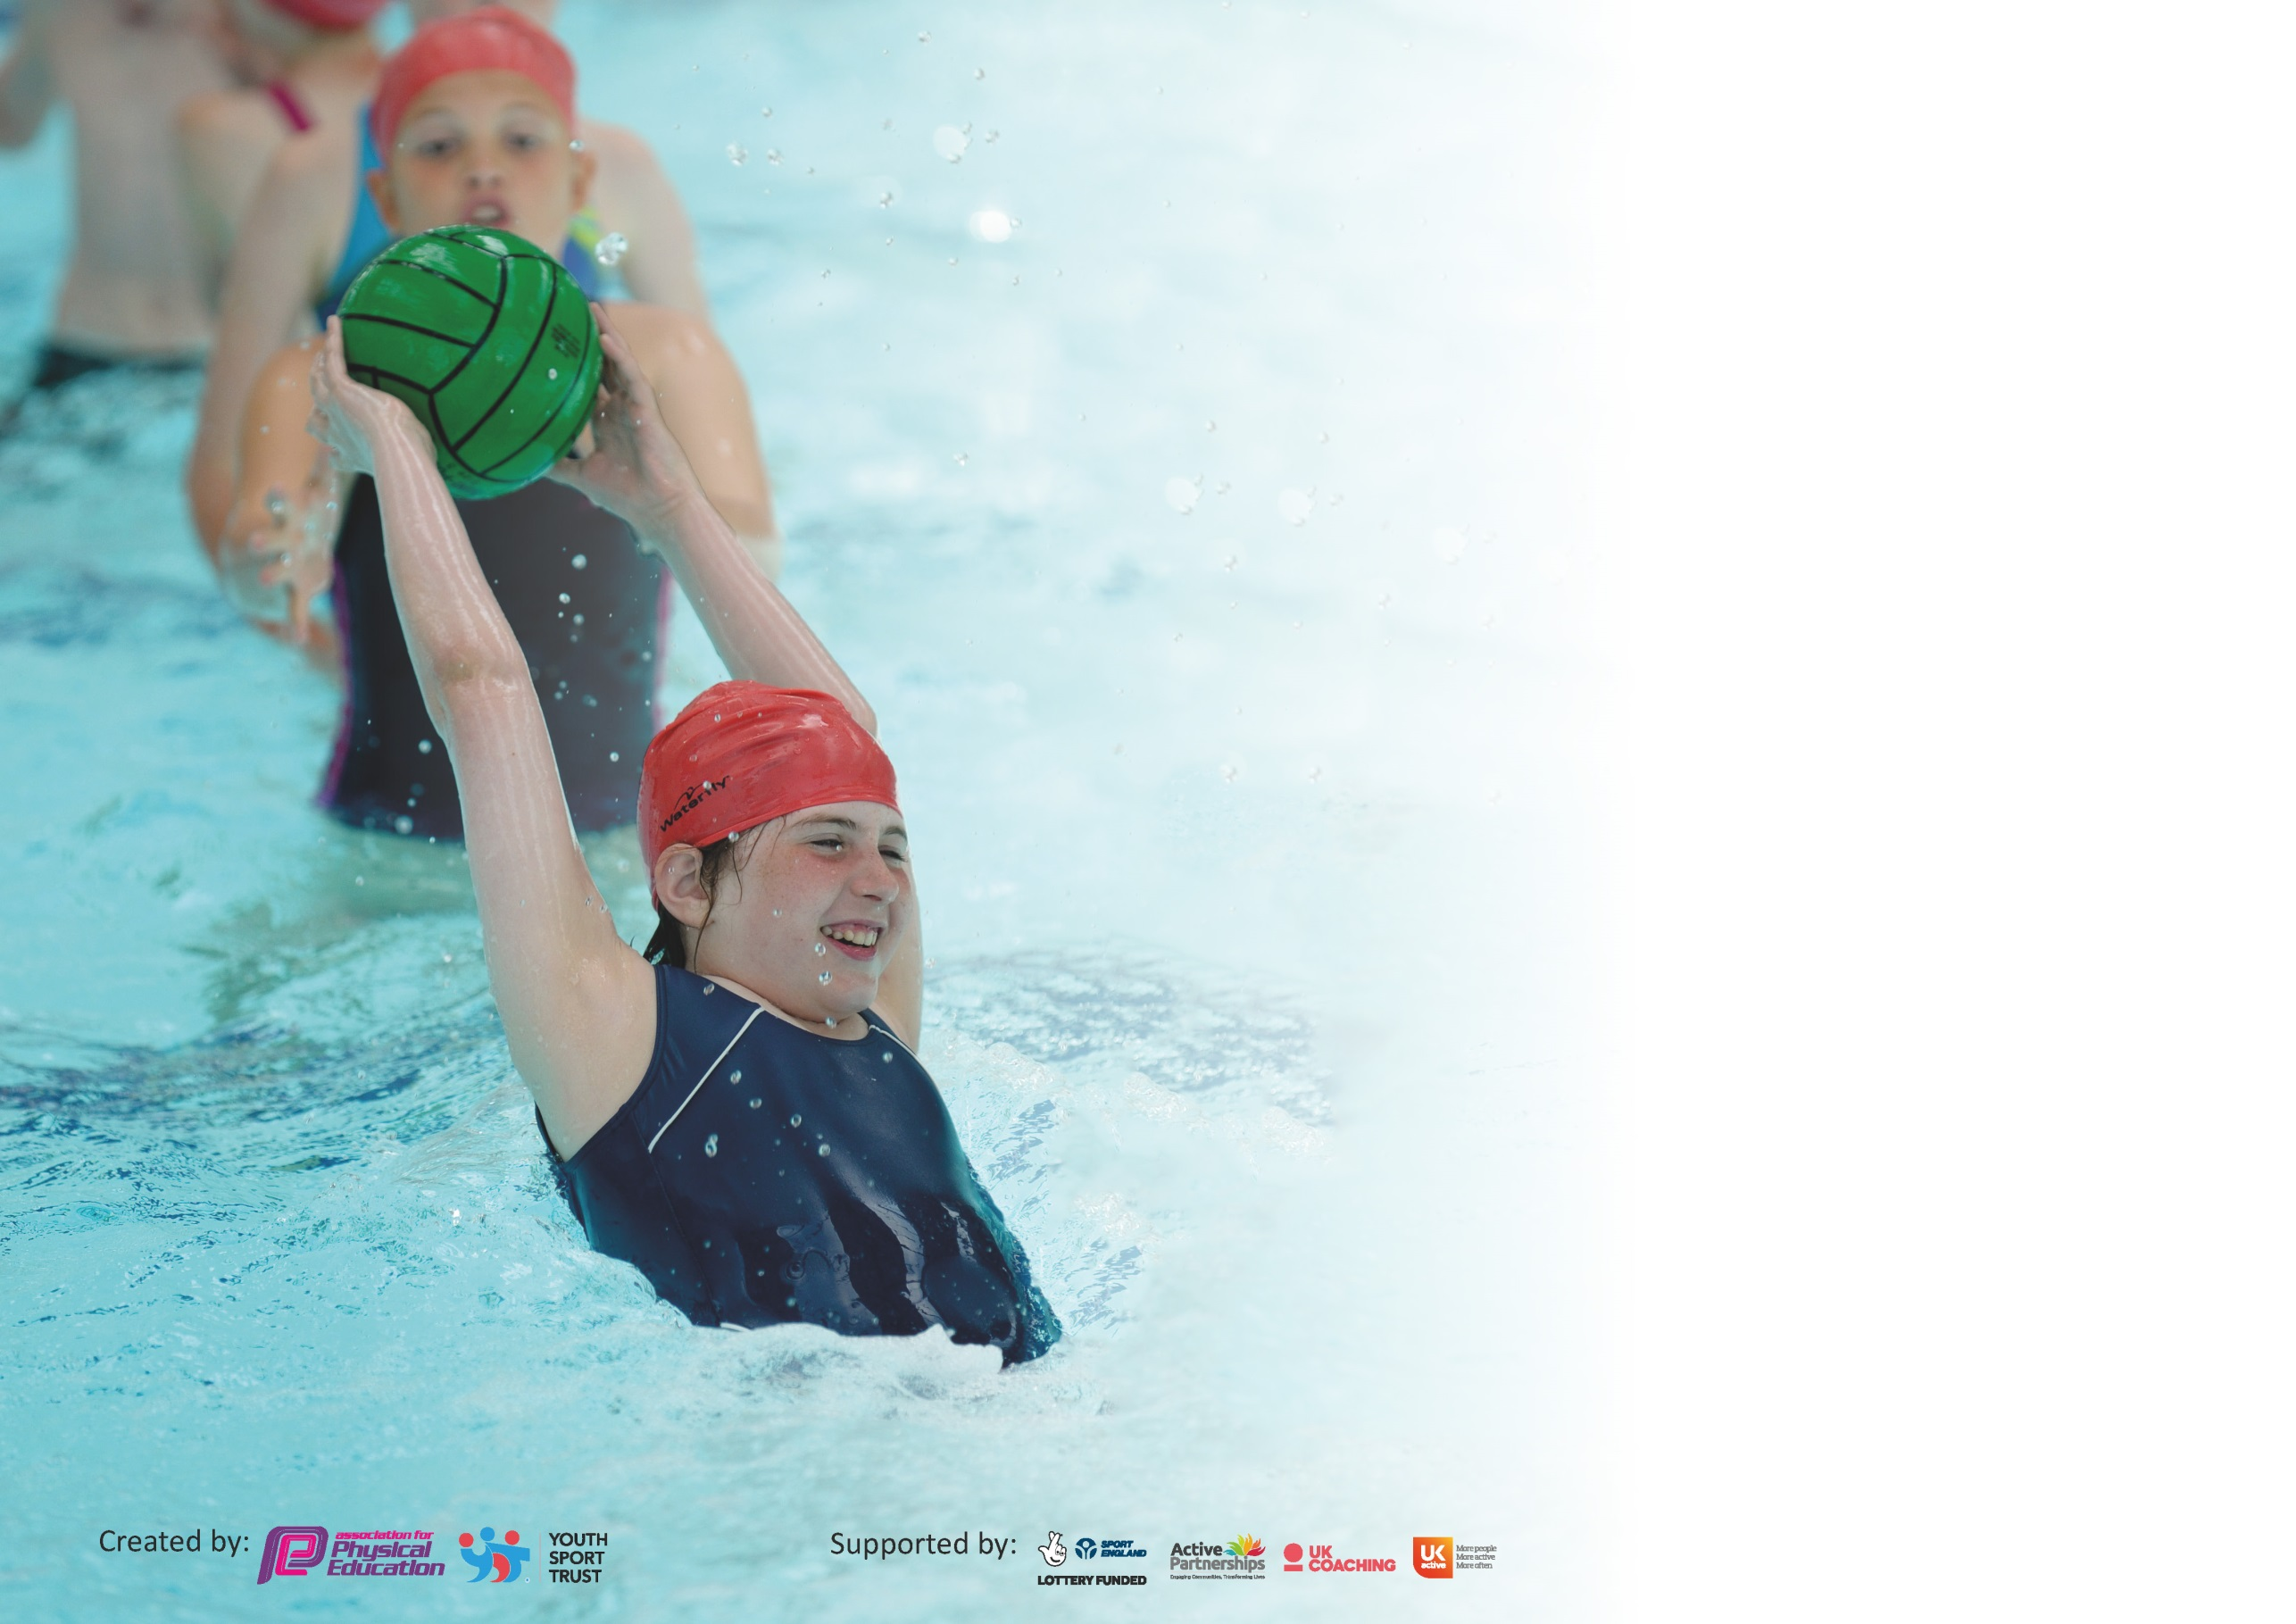

It is important that your grant is used effectively and based on school need. The Education Inspection Framework (Ofsted 2019 p64) makes clear there will be a focus on ‘whether leaders and those responsible for governors all understand their respective roles and perform these in a way that enhances the effectiveness of the school’.

Under the Quality of Education criteria (p41) inspectors consider the extent to which schools can articulate their curriculum (INTENT), construct their curriculum (IMPLEMENTATION) and demonstrate the outcomes which result (IMPACT).

To assist schools with common transferable language this template has been developed to utilise the same three headings which should make your plans easily transferable between working documents.

Schools must use the funding to make additional and sustainable improvements to the quality of Physical Education, School Sport and Physical Activity (PESSPA) they offer. This means that you should
use the Primary PE and Sport Premium to:

- Develop or add to the PESSPA activities that your school already offer
- Build capacity and capability within the school to ensure that improvements made now will benefit pupils joining the school in future years

Please visit gov.uk for the revised DfE guidance including the 5 key indicators across which schools should demonstrate an improvement. This document will help you to review your provision and to report your spend. DfE encourages schools to use this template as an effective way of meeting the reporting requirements of the Primary PE and Sport Premium.

We recommend you start by reflecting on the impact of current provision and reviewing the previous spend.

Schools are required to publish details of how they spend this funding as well as on the impact it has on pupils’ PE and sport participation and attainment by the end of the summer term or by 31st July 2020 at the latest.

We recommend regularly updating the table and publishing it on your website throughout the year. This evidences your ongoing self-evaluation of how you are using the funding to secure maximum, sustainable impact. Final copy must be posted on your website by the end of the academic year and no later than the 31st July 2020. To see an example of how to complete the table please click HERE.

Support for review and reflection - considering the 5 key indicators from DfE, what development needs are a priority for your setting and your pupils now and why? Use the space below to reflect on previous spend and key achievements and areas for development.

Key achievements to date until July 2019: | Areas for further improvement and baseline evidence of need:
- Children have access to a range of physical structured activities based on the fundamental skills during play and lunch times.  - We are continuing to provide extra provision outside the curriculum for swimming across Key Stage 2.  - Assisted places have enabled vulnerable children to attend school clubs, residential visits and enrichment visits.  - 45% of the y6 cohort achieved the statutory 25m target.  - A wide and varied extra-curricular program has been established, utilising the BFCitC coaching program to supplement our own after school activities.  - Staff more confident at delivering a range of activities through working alongside the BFCitC Coach and accessing CPD training.  - Inter school football competitions for girls/ boys and mixed football undertaken this year.  - Quality of the teaching of Dance has improved due to teachers and pupils participating in ballroom dancing competition.  - Enrichment opportunities have been implemented to help raise aspirations (Leisure Box, Blackpool Ballroom, BFC matches)  - PE/Sports profile has been raised across the school with the subject becoming embedded into daily school life.  - Clear curriculum maps established across school to allow for a broad and varied curriculum to be delivered with an increased range of sports to be taught.  - RAG rated swimming tracker created by subject leader to monitor progress.  - PE lessons and clubs include specific teaching of healthy lifestyles. Children have an increased knowledge of how they can keep healthy both mentally and physically. Charity links have reinforced this through BFCinC Kitchen. | - School’s Games Mark - Bronze Award  - Ensure there are multiple opportunities for children to be physically active throughout the school day, in addition to the PE curriculum.  - Embed Fundamental Movement Skills program across school. Ensure all children are competent at performing the 10 FMS which underpin the PE curriculum and accessing regular physical activity.  - Continue to develop whole staff skills in teaching a high quality PE curriculum. Access high quality CPD from Local authority and BFCitC.  - Further develop the range of competitive opportunities for ALL children – through BFCitC and through our local cluster schools.  - Organise and deliver intra school competitive sport as well as inter school competitions.  - Continue to develop the provision of sport in KS1.  - Increase the % of children achieving the swimming standards by the end of Year 6.

Meeting national curriculum requirements for swimming and water safety.
What percentage of your current Year 6 cohort swim competently, confidently and proficiently over a distance of at least 25 metres?  N.B. Even though your pupils may swim in another year please report on their attainment on leaving  primary school at the end of the summer term 2020. | 45%
What percentage of your current Year 6 cohort use a range of strokes effectively [for example, front crawl, backstroke and breaststroke]? | 45%
What percentage of your current Year 6 cohort perform safe self-rescue in different water-based situations? | 40%
Schools can choose to use the Primary PE and Sport Premium to provide additional provision for swimming but this must be for activity over and above the national curriculum requirements. Have you used it in this way? | Yes

Action Plan and Budget Tracking
Capture your intended annual spend against the 5 key indicators. Clarify the success criteria and evidence of impact that you intend to measure to evaluate for pupils today and for the future.

Academic Year: 19/20 | Total fund allocated: £17,400.00  Total expenditure: £19,276.43  PE Curriculum contribution:£1,876.43 | Date Updated: June 2020
Key indicator 1: The engagement of all pupils in regular physical activity – Chief Medical Officer guidelines recommend that primary school pupils undertake at least 30 minutes of physical activity a day in school |  |  |  | Percentage of total allocation:
 |  |  |  | £6,094.43 = 35%
Intent | Implementation |  | Impact
Your school focus should be clear what you want the pupils to know and be able to do and about  what they need to learn and to  consolidate through practice: | Make sure your actions to achieve are linked to your intentions: | Funding allocated: | Evidence of impact: what do pupils now know and what can they now do? What has changed?: | Sustainability and suggested next steps:
Ensure there are multiple opportunities for children to be physically active throughout the school day, in addition to the PE curriculum | Timetabled structured activities each lunch time run by a member of staff.  Team of play leaders established to deliver lunchtime activities to both KS1 and KS2 children.  Skip2Bfit 5 minute slot timetabled each afternoon for physical activity each day  Children to have had additional provision for swimming over and above the national curriculum requirements. This is so that Y6 meet the national expected standard. | £1,094.43  £5,000.00 | 70% of children accessing the activities each week  6 leaders helping to deliver daily games which all children can access.  Every child accesses a 5 minute skipping slot each day.  Children in Year 5 are beginning to meet the national expected standard for children in Year 6. This is through targeted extra intervention in years 4/5/6. | Targeted lunchtime/ after school clubs for least active, vulnerable children and sports teams. Meet with children to discuss (pupil voice).  Ensure there are multiple opportunities for children to be physically active throughout the school day, in addition to the PE curriculum (daily skip/Mile a Day/ Yoga/Supermovers).
Key indicator 2: The profile of PESSPA being raised across the school as a tool for whole school improvement |  |  |  | Percentage of total allocation:
 |  |  |  | £7,400.00 = 42.5%
Intent | Implementation |  | Impact
Your school focus should be clear what you want the pupils to know and be able to do and about  what they need to learn and to  consolidate through practice: | Make sure your actions to achieve are linked to your intentions: | Funding allocated: | Evidence of impact: what do pupils now know and what can they now do? What has changed?: | Sustainability and suggested next steps:
Provide a range of competitive opportunities for children with cluster schools and events organised by BFCitC. | Access the current BFCitC competition programme.  Target KS1 children to attend festival / friendly events  Provide regular Level 1 competitions within school ie after school clubs. | £6,500  £ 900 | 12 events accessed in a range of activities including cluster, participation, least active, infant and SEN specific events.  All KS2 have access to competition within school.  Children have attended an event accessing 2 x festivals.  Buy into the BFCitC Primary Stars Programme  Coach delivers activities which focus around social skills/interaction/teamwork/self-esteem to a targeted group of children.  BFCitC to deliver specific SEND PE programme weekly.  BFCitC to deliver 2 x after school clubs with element of inhouse competition embedded into it.  Children access additional coaching at lunchtimes including football, cricket and basketball.  Yrs 5 & 6 access 8 hours of Bikeability training through Go Velo. | Develop competitive sport and competitions for children across both Key Stages.  Organise and deliver intra school competitive sport as well as inter school competitions across both key stages.

Key indicator 3: Increased confidence, knowledge and skills of all staff in teaching PE and sport |  |  |  | Percentage of total allocation:
 |  |  |  | £1,590.00 = 9%
Intent | Implementation |  | Impact
Your school focus should be clear | Make sure your actions to | Funding | Evidence of impact: what do | Sustainability and suggested
what you want the pupils to know | achieve are linked to your | allocated: | pupils now know and what | next steps:
and be able to do and about | intentions: |  | can they now do? What has
what they need to learn and to |  |  | changed?:
consolidate through practice:
Continue to develop whole staff skills in teaching a high quality PE curriculum. Access high quality CPD from Local Authority and BFCitC service level agreement. | Whole school training on Gymnastics.  Purchase I-Pads to enable to be used within the PE curriculum to help more formative/summative assessment and enable Subject Leader to have a clearer picture of the children’s skills. Use footage to help inform where intervention / CPD may be needed. | £150  £1,440 | Increase in confidence in staff delivery across the school.  Children able to access a high quality curriculum.  Assessment clarification is robust and easier for Subject Leader to monitor standards in PE. | Additional CPD training on dance, games and gymnastics for teachers/ TAs.  Subject leader development courses CPD
Key indicator 4: Broader experience of a range of sports and activities offered to all pupils |  |  |  | Percentage of total allocation:
 |  |  |  | £4,192.00 = 24%
Intent | Implementation |  | Impact
Your school focus should be clear | Make sure your actions to | Funding | Evidence of impact: what do | Sustainability and suggested
what you want the pupils to know | achieve are linked to your | allocated: | pupils now know and what | next steps:
and be able to do and about | intentions: |  | can they now do? What has
what they need to learn and to |  |  | changed?:
consolidate through practice:
Additional achievements:  Continue to develop a wide and varied curriculum /extracurricular programme.  All children to be able to access as many opportunities and experiences as possible. | Children to visit Leisure Box for 2 x morning sessions (60 children) in total.  Chair of Governors (Mrs. W. Harvey) observed a morning session at the Leisure Box with both KS1/2 children to verify quality of provision and discuss standards with J.Peel.  Children to access facilities which enable a wider provision to be facilitated.  KS2 Children (mixed year groups) to attend 3 x Premier League Football Matches. To experience competitive football; 1 hours tuition; matchday experience I.e. 7 a side football at half time in front of a Stadium crowd; understanding of safety in large crowds and of acceptable behaviours etc.  Y6 Children to visit Whitehough Outdoor Leisure centre to experience an overnight stay and experience hill walking, orienteering and bushcrafts. | £2,844.00  £ 750.00  £ 598.00 | Children enjoy a wider range of provision in an appropriate environment where they can experience a full size pitch; cricket nets and dance / basketball/ badminton area.  Children have had the opportunity of a live sporting event and the pleasure / challenges that can bring. Greater understanding of careers in sport.  Children have also had the opportunity of playing on a premier league football pitch in front of a large crowd.  Children have experienced a night away from home.  They have ‘climbed’ Pendle Hill and have a greater understanding of the physical energy used when physical activities are over a longer period of time.  They have more confidence in using a compass and maps in order to discover a new place. Children developed their orienteering skills in the outdoors. | Further develop children’s opportunities to access sports outside of school.

Key indicator 5: Increased participation in competitive sport |  |  |  | Percentage of total allocation:
 |  |  |  | £450.00 = 2.6%
Intent | Implementation |  | Impact
Your school focus should be clear | Make sure your actions to | Funding | Evidence of impact: what do | Sustainability and suggested
what you want the pupils to know | achieve are linked to your | allocated: | pupils now know and what | next steps:
and be able to do and about | intentions: |  | can they now do? What has
what they need to learn and to |  |  | changed?:
consolidate through practice:
Provide a range of competitive opportunities for all children across KS1 and KS2. | Children to access 12 events in a range of activities including cluster, participation, least active, infant and SEN specific events.  Matchday experience i.e. 7 a side football at half time in front of a Stadium crowd x 2.  School Sports Day – children to access athletics in a local athletic arena.  Children to take part in the Cluster celebration day – carousel of sport activities provided by teaching staff and outside providers. | (as per KI2)  (as per KI4)  £ 150.00  £ 300.00 | 12 events have accessed in a range of activities including cluster, participation, least active, infant and SEN specific events. Experience of sport in a range of venues.  Children have had the opportunity of a live sporting event and the pleasure / challenges that can bring.  Children able to utilise their athletic skills in a large scale athletic arena with running track; sand pit and high jump.  Children have taken part in a competitive event with 11 other schools.  Children have had access to high quality outside coaches. | Increase the range of competitive opportunities for all children across KS1 and KS2.

Signed off by
Head Teacher: | Kathryn Ellidge
Date: | 12th February 2020
Subject Leader: | Jasmine Peel
Date: | 10th June 2020
Governor: | Wendy Harvey
Date: | 05 July 2020

